January 2018
A Guide to Completing the Form R

It is important that trainees complete a Form R for both training and Revalidation purposes.
A Form R is required from every new trainee joining a training programme, and at every ARCP thereafter (at least once per year). Each ARCP should have a new Form R which should be completed beforehand, but no earlier than 30 days before the ARCP.
The Form is split into two sections; Part A is for personal details and must be completed each time a new Form R is completed, even if the details have not changed since the last Form R. Part B includes questions about significant event, complaints, compliments, probity and health. In addition there is a scope of practice section where trainees are required to list their past and present employers, training placements, time out of programme, advisory or voluntary roles undertaken as a registered medical practitioner since the last ARCP or appraisal.
Below is an annotated guide to completing the Form R. Should you have any further questions about the Form R please contact:
- For trainees joining the GP training programme and completing the Form R for the first time: sev.GPSchool.sw@hee.nhs.uk
- For trainees completing a Form R in advance of their ARCP: sev.GPSupport.sw@hee.nhs.uk
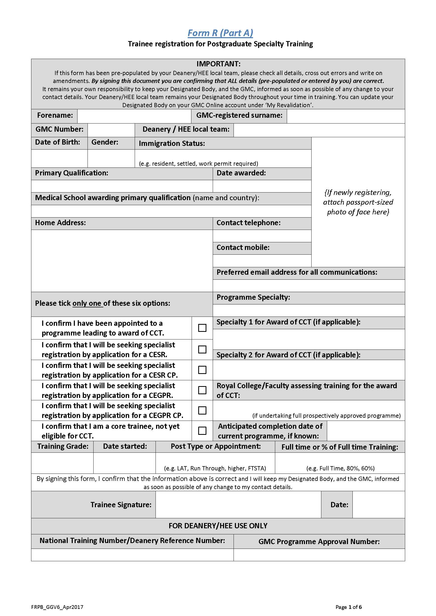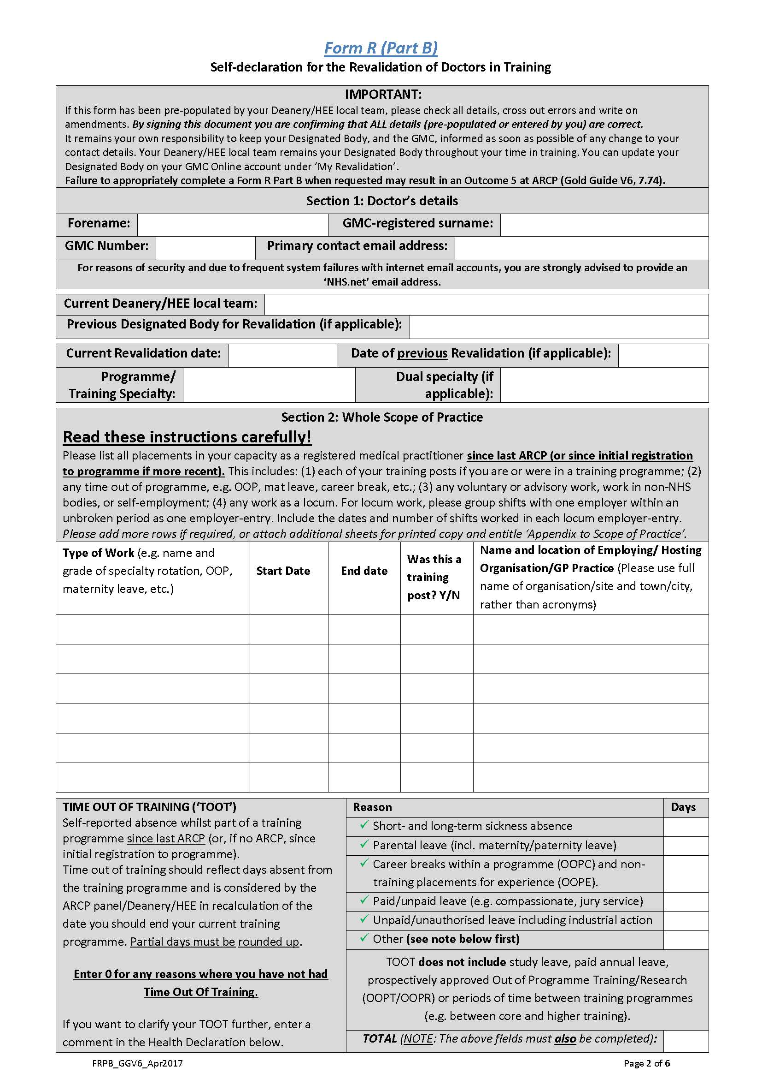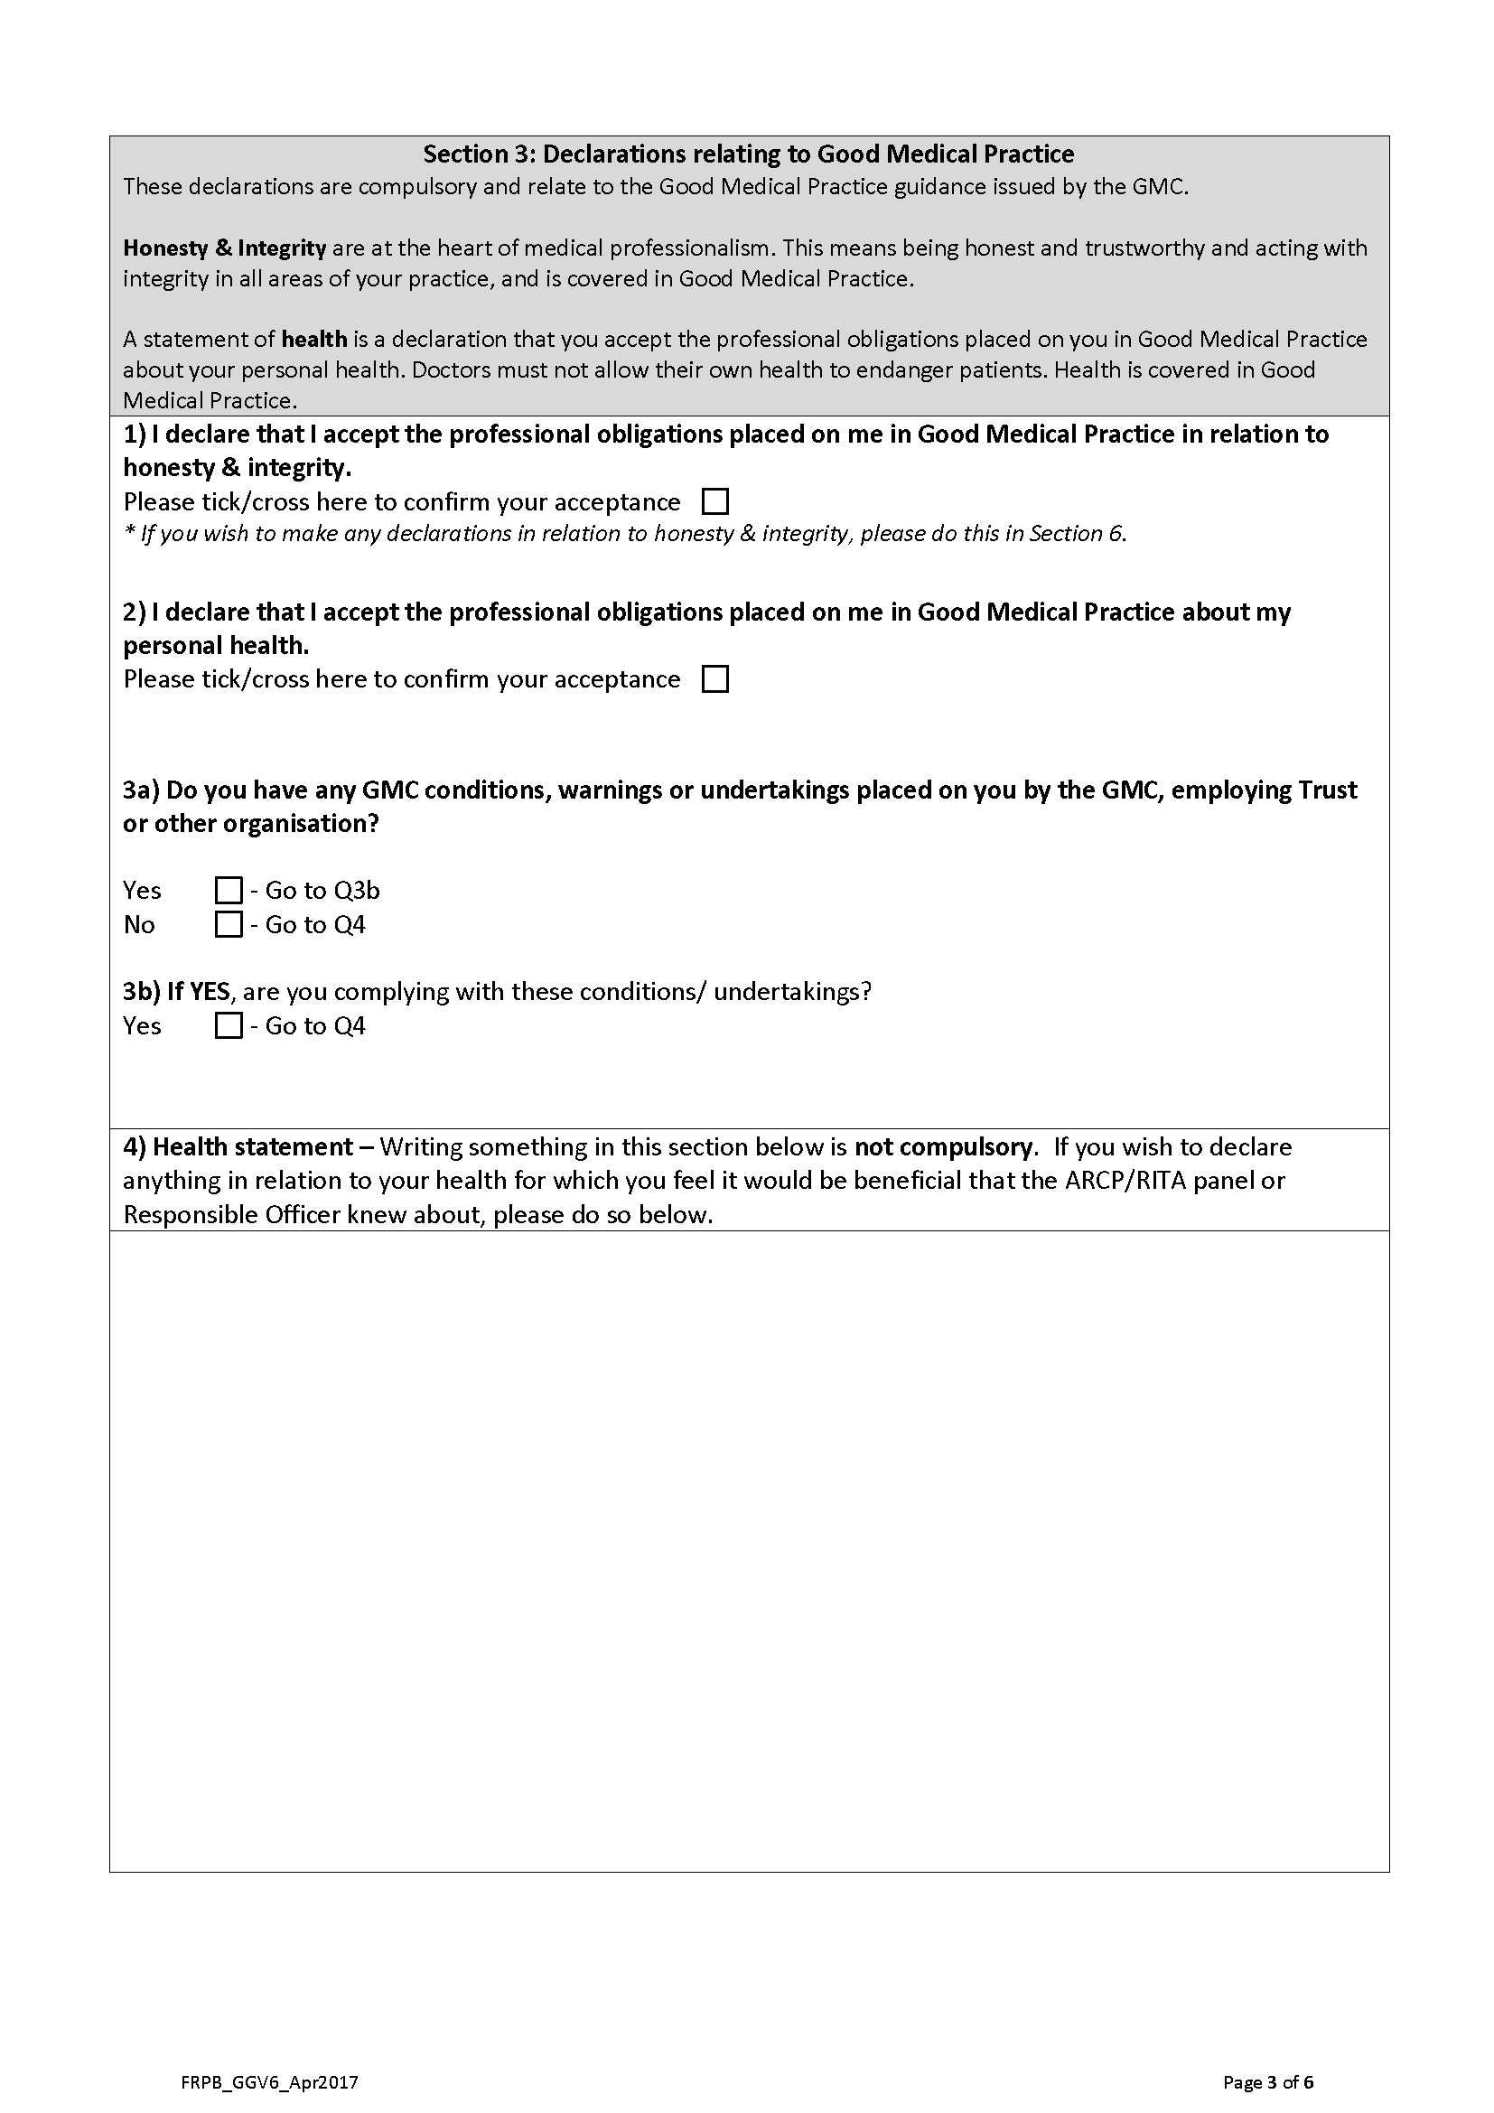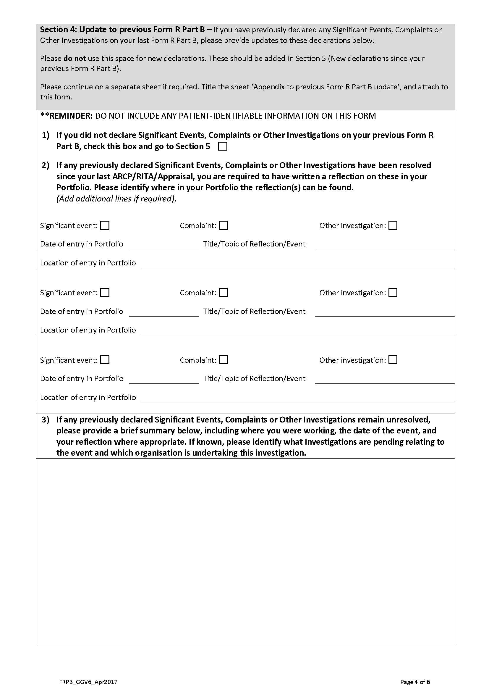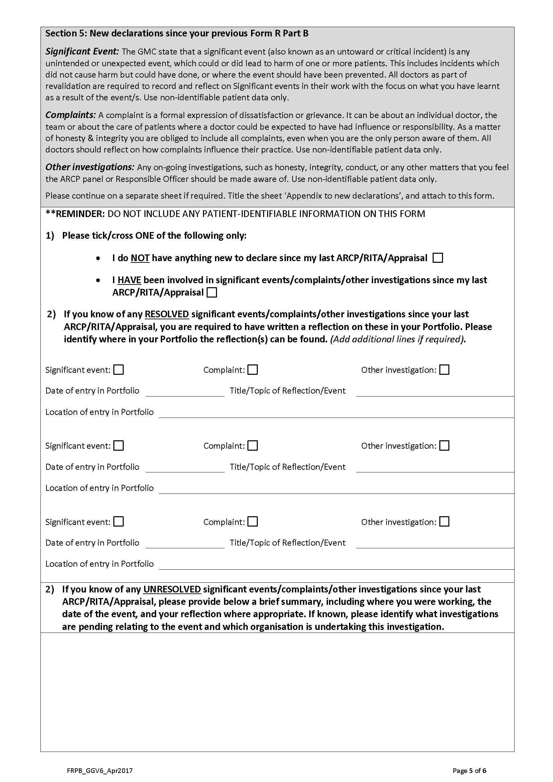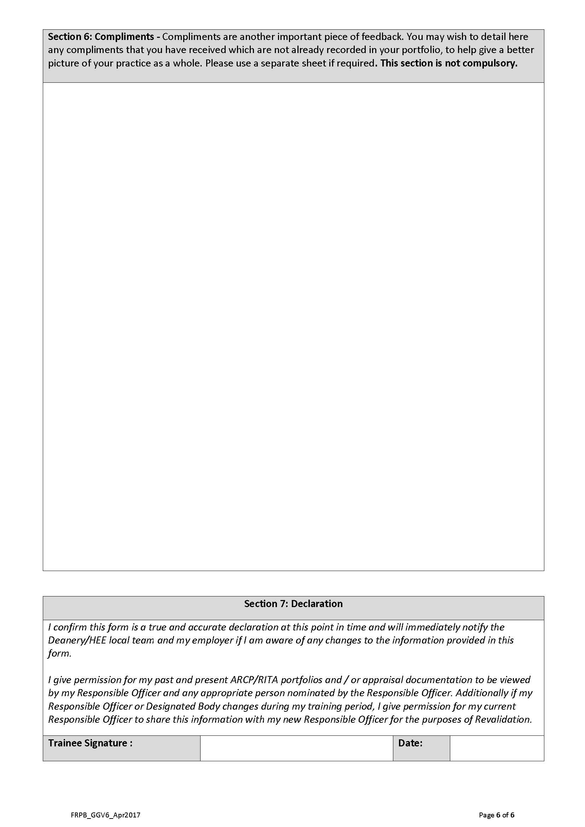
Most trainees will need to tick this box if you are on the standard 36m WTE GP training programme. Only trainees who have specifically applied to shorten their training programme by way of the CEGPR or CEGRP (CP) process will need to tick anything else.
The training grade for new starters will be ST1, date started will be your first official day of training, post type will be ‘Run Through’ and finally unless you have applied for LTFT training, the last box will be Full Time.
Remember to sign and date this page.
You can find this from your TeP.
Enter ‘RCGP’ here.
Complete this table with your posts since last ARCP or since initial registration to GP training if more recent. Please include time OOP and maternity leave in this section.
This section is very important for calculating any necessary changes to CCT dates. Please complete it carefully.
Include all days of TOOT, not just working days.
If you have not taken any TOOT, we still need a ‘0’ in every box, especially the total box.
For longer periods of TOOT, the date to date calculator on this website can be useful for working out the number of days: www.timeanddate.com
This needs to be filled in even if repeating information from page 1.
Ensure these boxes are ticked.
The GMC define a significant event (also known as an untoward or critical incident) as any unintended or unexpected event, which could or did lead to harm of one or more patients. This includes incidents which did not cause harm but could have done, or where the event should have been prevented. These would normally have led to a formal trust or practice investigation/meeting.
Most entries entered in the learning log as (educational) SEAs would not meet these criteria.

See previous section for definition of SEAs. Please note that this includes SEAs that have been resolved.

Remember to sign and date the form. Please note the Form R should not be completed earlier than 30 days before the date of the ARCP Panel.

After your first Form R has been completed prior to the start of GP training, please send it to SEVGPSchool.sw@hee.nhs.uk
For Form Rs completed for an ARCP, please upload it to the Learning Log section of your TeP as a ‘course/certificate’. Please ensure that it is ‘shared’ so that the ARCP panel can view it. Do not upload it to your Personal Library as this cannot be viewed by the panel members.

